Library System
  - Ahmad Shahzad – T00269209
  - Server Side Project

Database
.sql file name: librarysys.sql
Database Name: librarysys

Table Structure & Data
Tables:
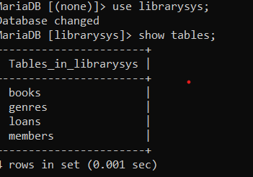

Books Table Structure:
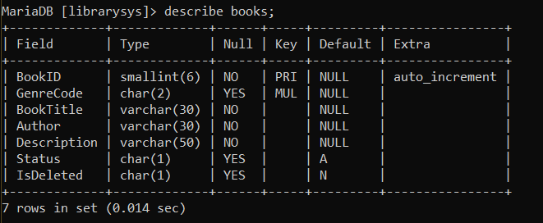

Genres Table Structure:
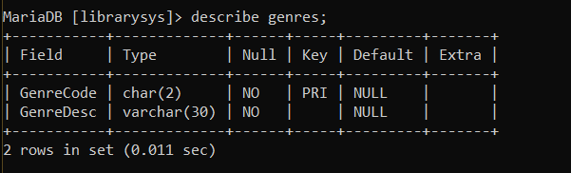

Members Table Structure:
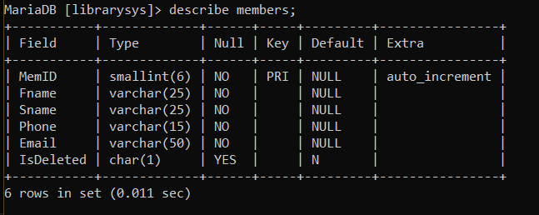

Loans Table Structure:
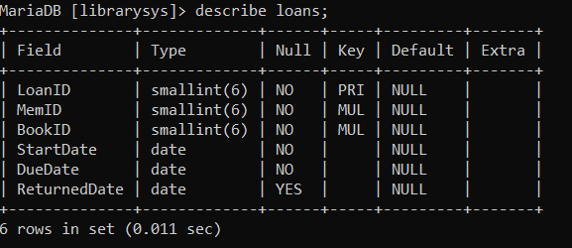

Book Table Data:
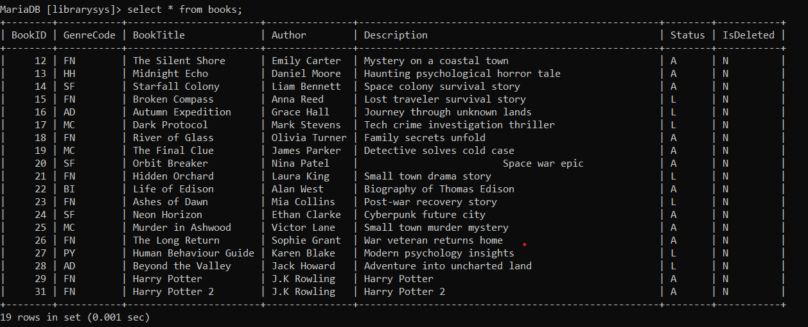
Genres Table Data:
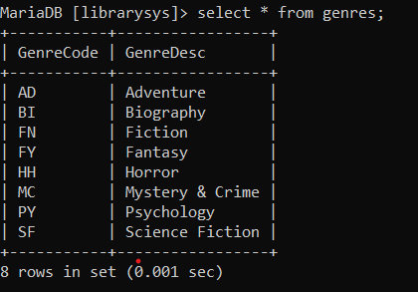
Members Tale Data:
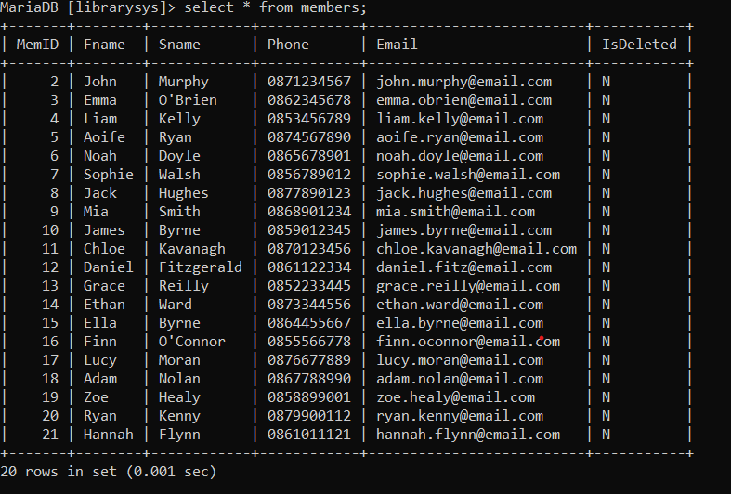
Loans Table Data:
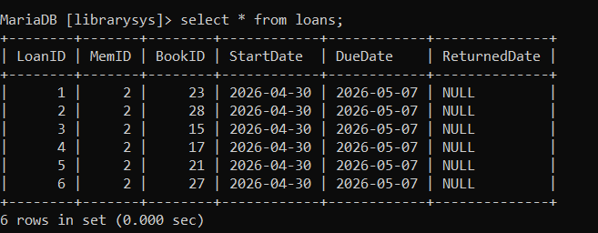

Insert, Update, Delete etc

Select
One Select can be found at the start of “LoanBook.php” process where the user enters the name of the book they’re looking for.
- User Enters the book title they’re looking for and submits the form which goes to Main.php, which processes server requests
- This form then takes the user’s input as an argument and passed it to the FindAllBooks method in the Book class found in Classes.php
- The Method get’s all rows that match the user’s input and return an array of data from which Book Objects are created and stored in an Array Called $Books
- These Book Objects are then looped through and taking their information and converting to the html to be shown as a table.
- Table rows and then returned to LoanBook.php that contains a table.

Insert
An Insert process can be found in AddBook.php
- User enters a book title, author, selects genre and description and submits form. Submitting form runs the ConfirmAddBook method found in JsMain.js which shows an alert to confirm details. If the user presses “OK” , the form get submitted
- Request method is sent to Main.php $_POST[‘AddBook’]
- The inputs are Validated by using the ValidateBook method found in Validation.php, which sends back an array of errors if any found.
- If there are no errors it proceeds and then checks if that book already exists in the DB using the CheckBookExists method found in Validation.php
- If another book of that book title and author exist i.e count > 0 then it returns an array of the error or else returns an empty array.
- If No errors are found it proceeds and created a book object and runs the AddBook method which adds the book to the DB

Update
The Update process can be found in UpdateBookForm.php
- User searches a book by BookID and submits form
- Main.php receives the form $_POST[‘SearchBook’]
- The user’s input is validated for the ID using the ValidID method taking the ID and type ( Type of validation eg Book, Member ID? Etc).
- ValidID returns an array with errors if found or an empty array if no errors found.
- If no errors around found, the book is retrieved using it’s book id from the method FindBookByID found in the Book class in classes.php which returns a book object or null if nothing found
- This book is stored in a variable called $RetrievedBook
- If $RetrievedBook is empty the errors array is populated with an error

Update Part:
- If $RetrievedBook is not empty the second form ‘UpdateBookk’ is filled with the Book data retrieved
- User makes changes and submits form which then runs the ConfirmBookUpdate method found in JsMain.js that displays a confirm message. If the user clicks “OK” then the form is submitted and processed by Main.php at $_POST[‘UpdateBook’]
- Users inputs is validated using the method ValidateBook
- If no errors exist it proceeds to check if the book already exists in the system so you cant have to of the same books eg if you had a book called Harry Potter and another book called Harry Potter 2 and you tried to change Harry Potter 2 to just Harry Potter, it would throw an error.
- If No errors a new book object is created assigning all attributes
- The UpdateBook method found in the Book class in classes.php, is run on the book object

Delete
The delete process can be found in DeleteBookForm.php
- Same process is followed by looking for and retrieving book by it’s id as in UpdateBookForm.php
- Data is displayed in the second form “DeleteBook”
- User presses “delete book” button which then runs ConfirmBookDelete method found in JsMain.js, displaying a confirm message.
- User presses “Ok” and the form get submitted and processed by Main.php at “DeleteBook”
- A new book object is created using the data from the form
- A check is performed to check the book status. If status is “L” (loaned) the error array is populated with an error
- If status is “A” then the RemoveBook method found in the book class in classes.php is run on the book object
- The method uses the object’s book id to find the book and perform a soft delete

Process
The Process can be found in LoanBook.php
- Book available are searched as explained in “Select” process previously
- Retrieving Book and Member details
- Users enters the Book ID and Member ID to retrieve details from DB
- Request is sent and processed by Main.php at $_POST[‘RetrieveDetail’]
- Book ID is validated using the ValID method found in Validation.php
- If no errors found Member ID is validated using the ValidID method found in Validation.php
- If both are ids are valid then, the book is retrieved using the FindBookByID method found in the Book class in classes.php, which returns a book object
- A check is performed to see if the a book object was brought back. If it’s null an error is added to the error array
- If no error is found then the Member is retrieved using the GetMemberByID method found in the member class in classes.php
- A check is performed if a member object was brought back. If no object is found then error is added to the error array
- Both Book and Member are stored in variables called $RetrievedBook and $RetrievedMember
- Conform Loan form
- Details of the Book and Member are displayed in the LoanBook form
- User selects return date for the loan and submits form which runs the ConfirmLoan method from JsMain.js. If the user presses “Ok” on confirmation alert the form is submitted and processed by Main.php
- LoanBook form is processed at $_POST[‘LoanBook’] in Main.php
- Form data is Validated using the method ValidForm found in Validation.php. Valid form checks for any errors in the input and if found populated the errors array with appropriate error
- If no errors are found a check is performed to see how many loans the member has using the NoLoans method from the Loans class in classes.php
- If the no. of loans of exceeds 5 then the error array is populated with an error
- If no errors are found then a new loan loan object is created and populated with appropriate data
- The AddLoan method from the Loan class in classes.php is then run on the loan object
- The AddLoan method changes the book status to “L” for the book being loaned, and adds a new loan to the DB

